pwd- It shows the present working Directory.

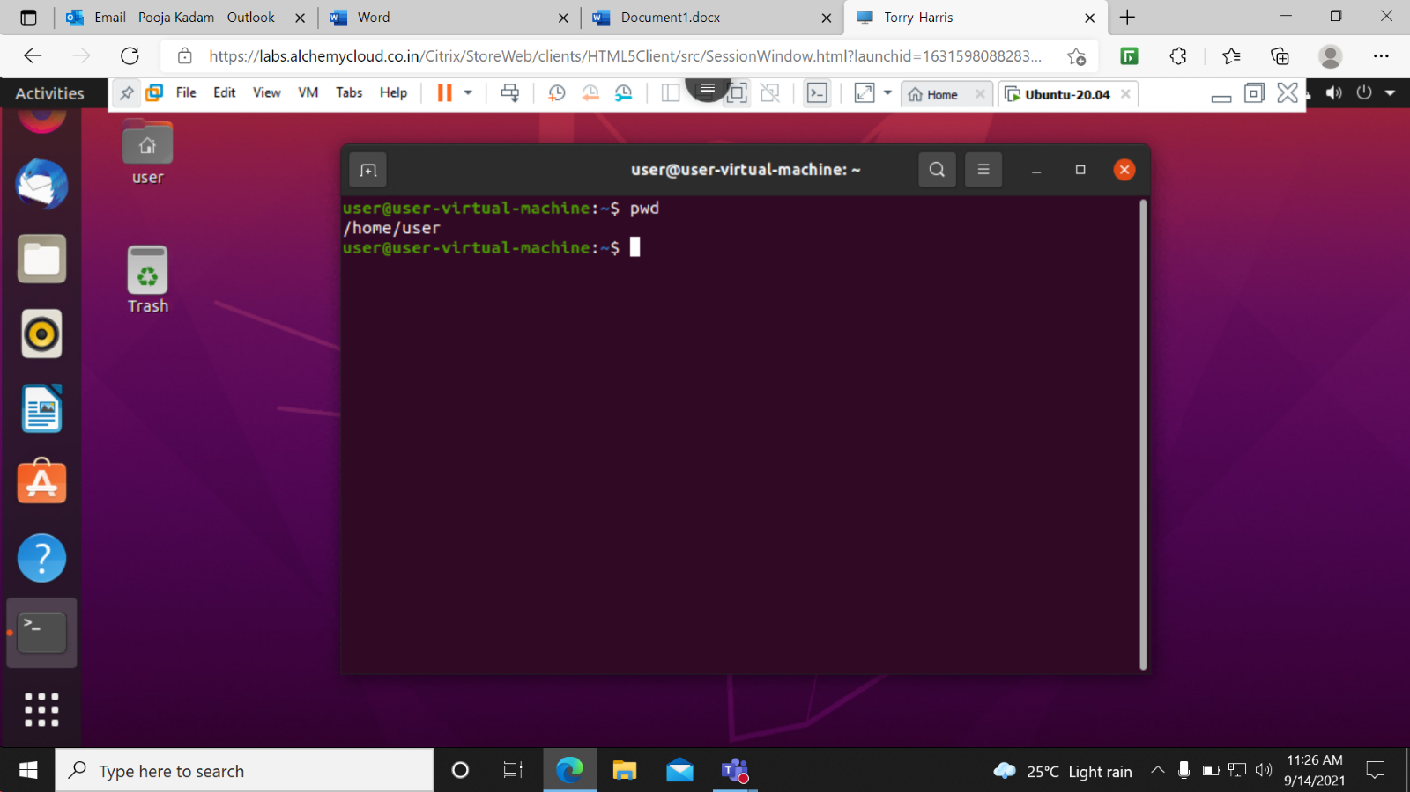

clear- It clear’s the Terminal screen.

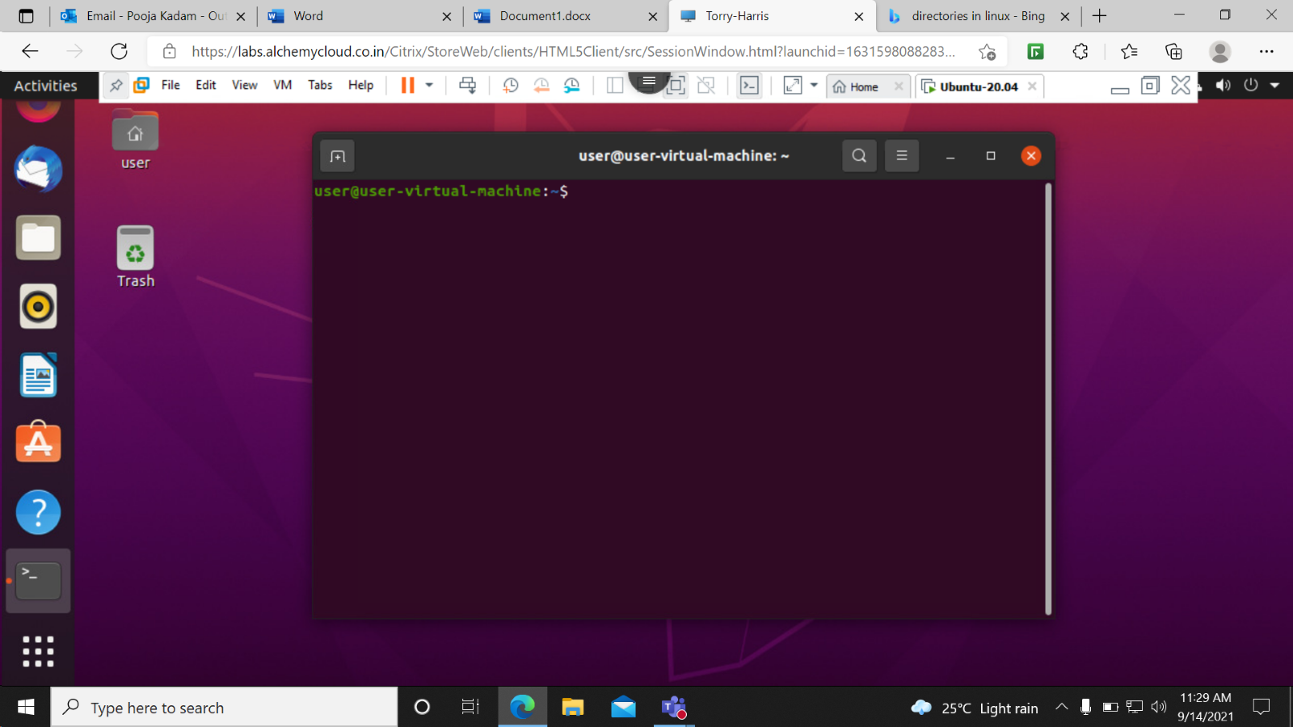

ls- It shows the list of all Directory which are present on the current Directory.

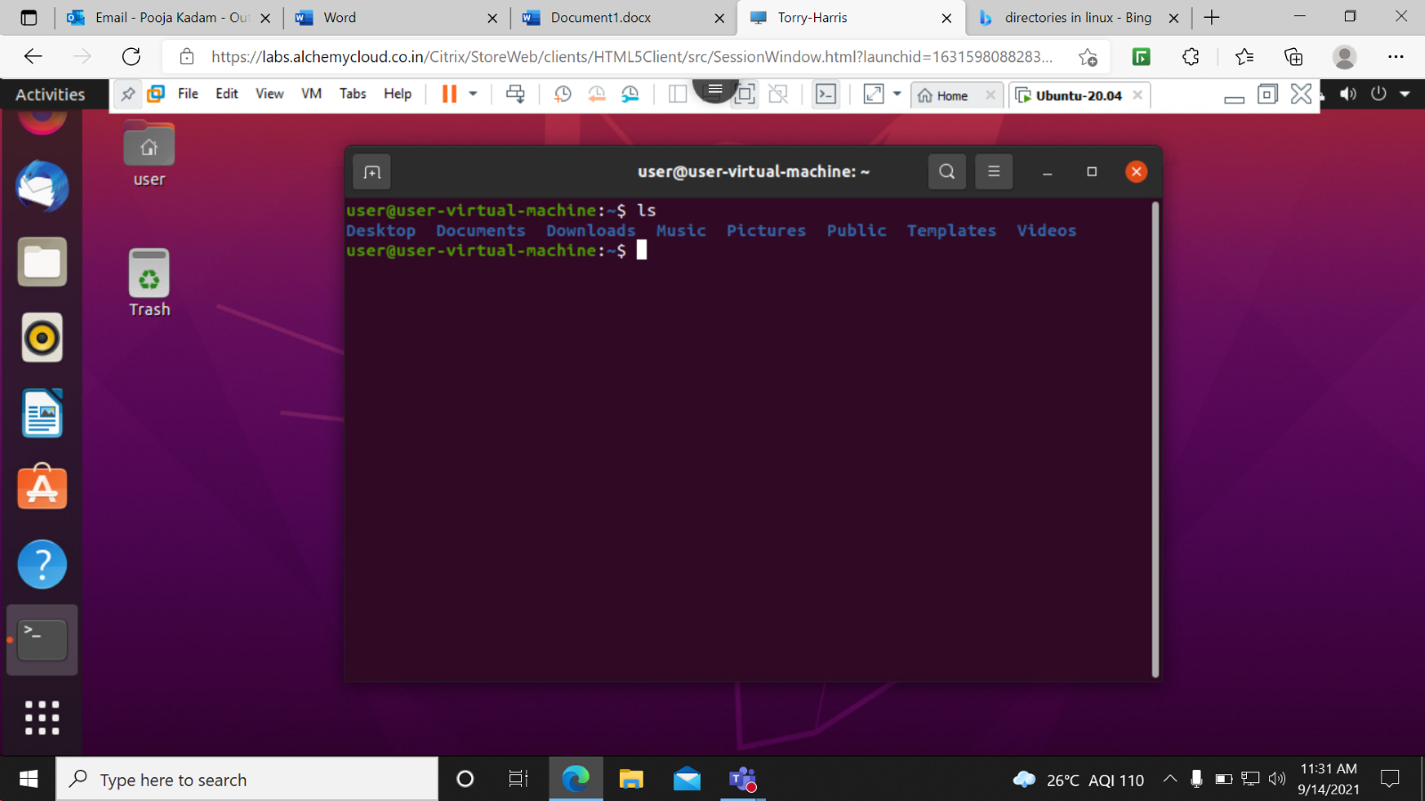

ls -l –It shows all folder in a long way.

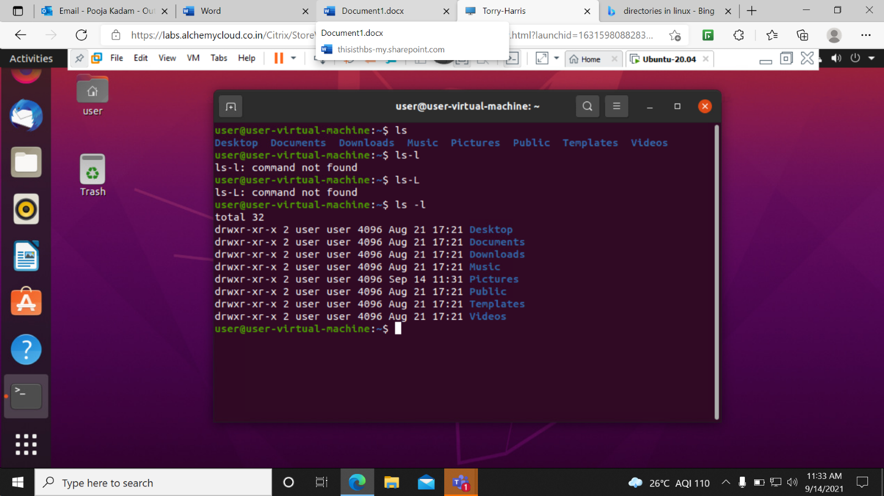

cd /- It is used to change the directory to root.

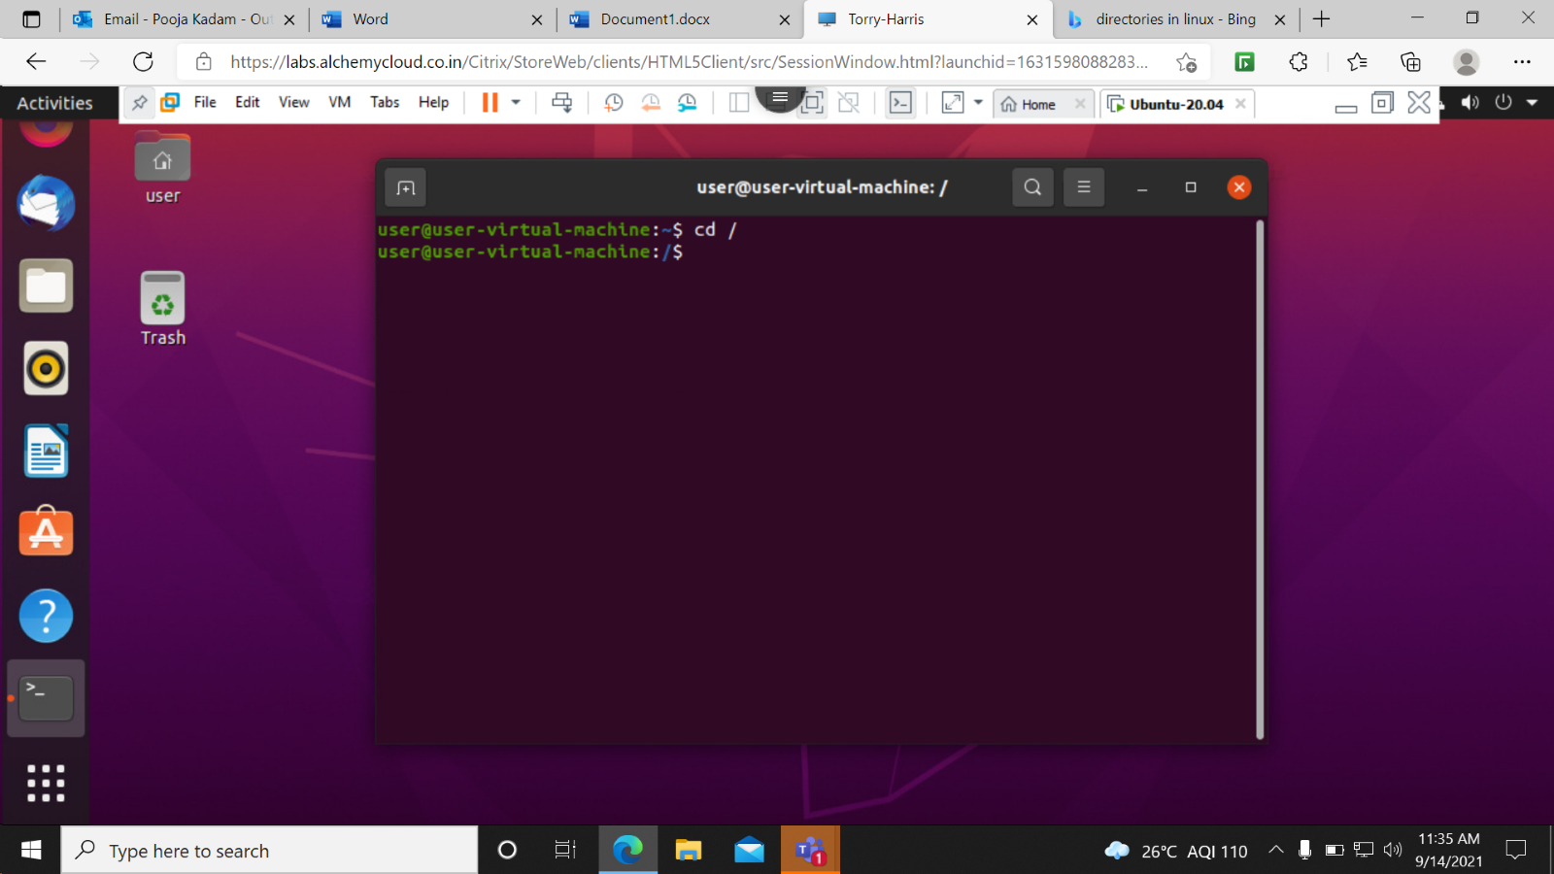

ls -f –It shows all folders without any format as well as without sort.

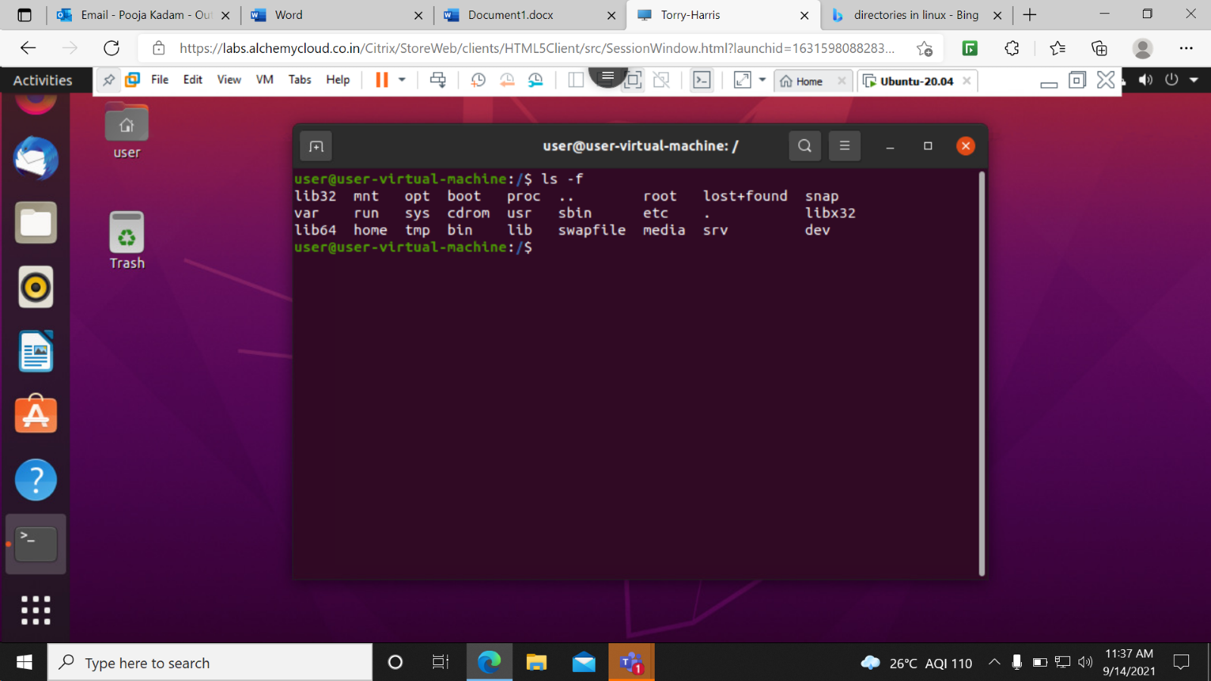

ls -a –It shows all folders in sorted format.

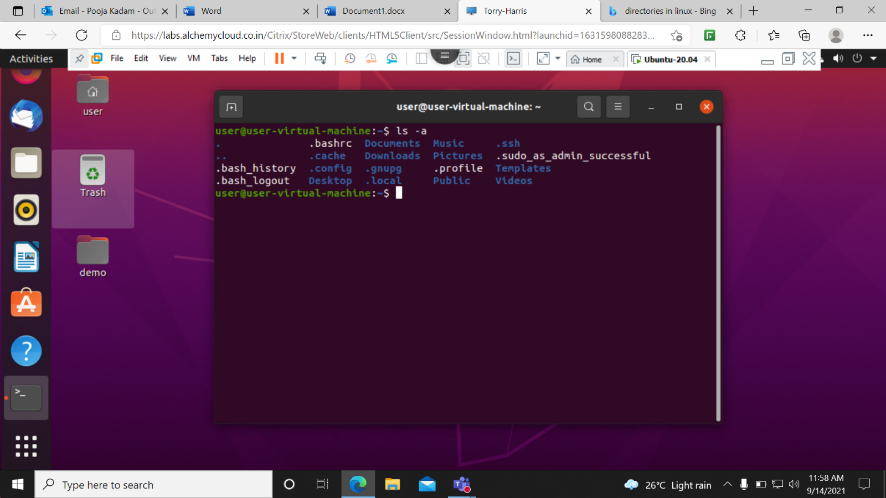

exit- Used to exit from the terminal to the main window.

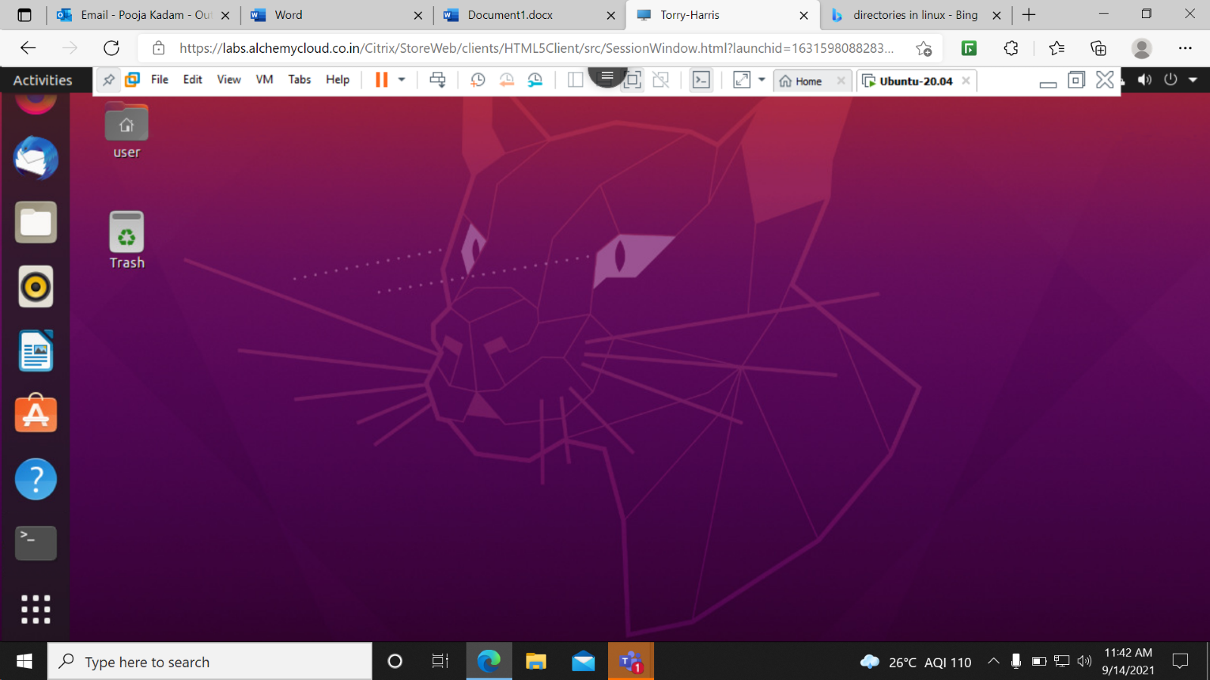

man ls-It shows the manual of the ls command.

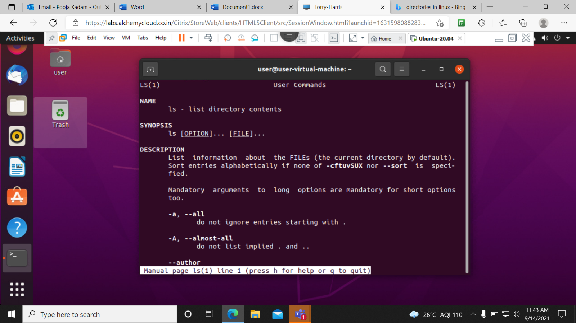

ls --help –It shows the details of ls command to help us out.

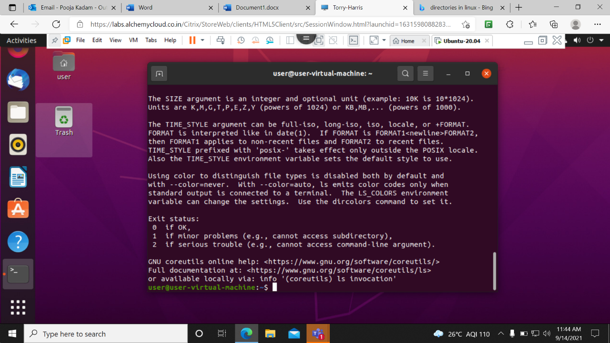

echo ‘ ’-used to print.

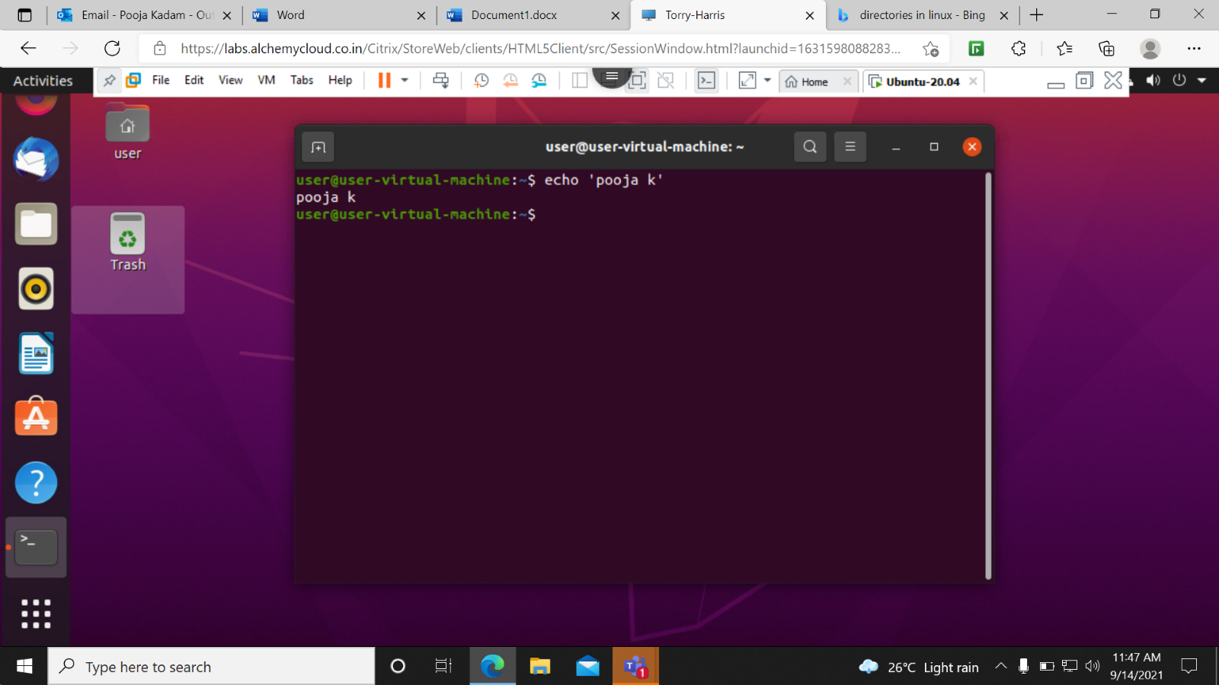

mv Demo to demo-Use to change the name of the folder from Demo to demo.

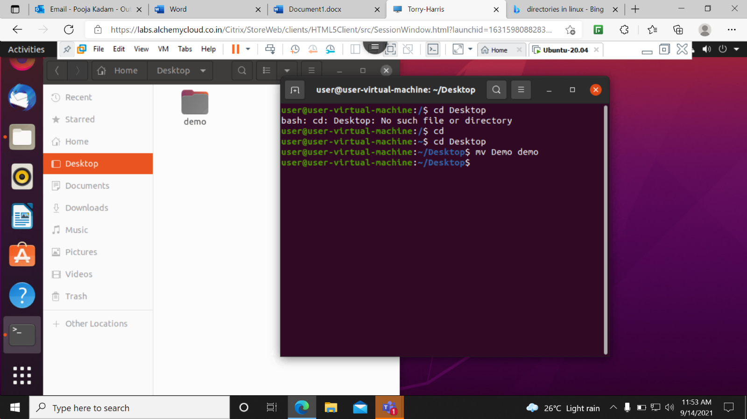

Cd .day2- this is used to access the hidden folder.

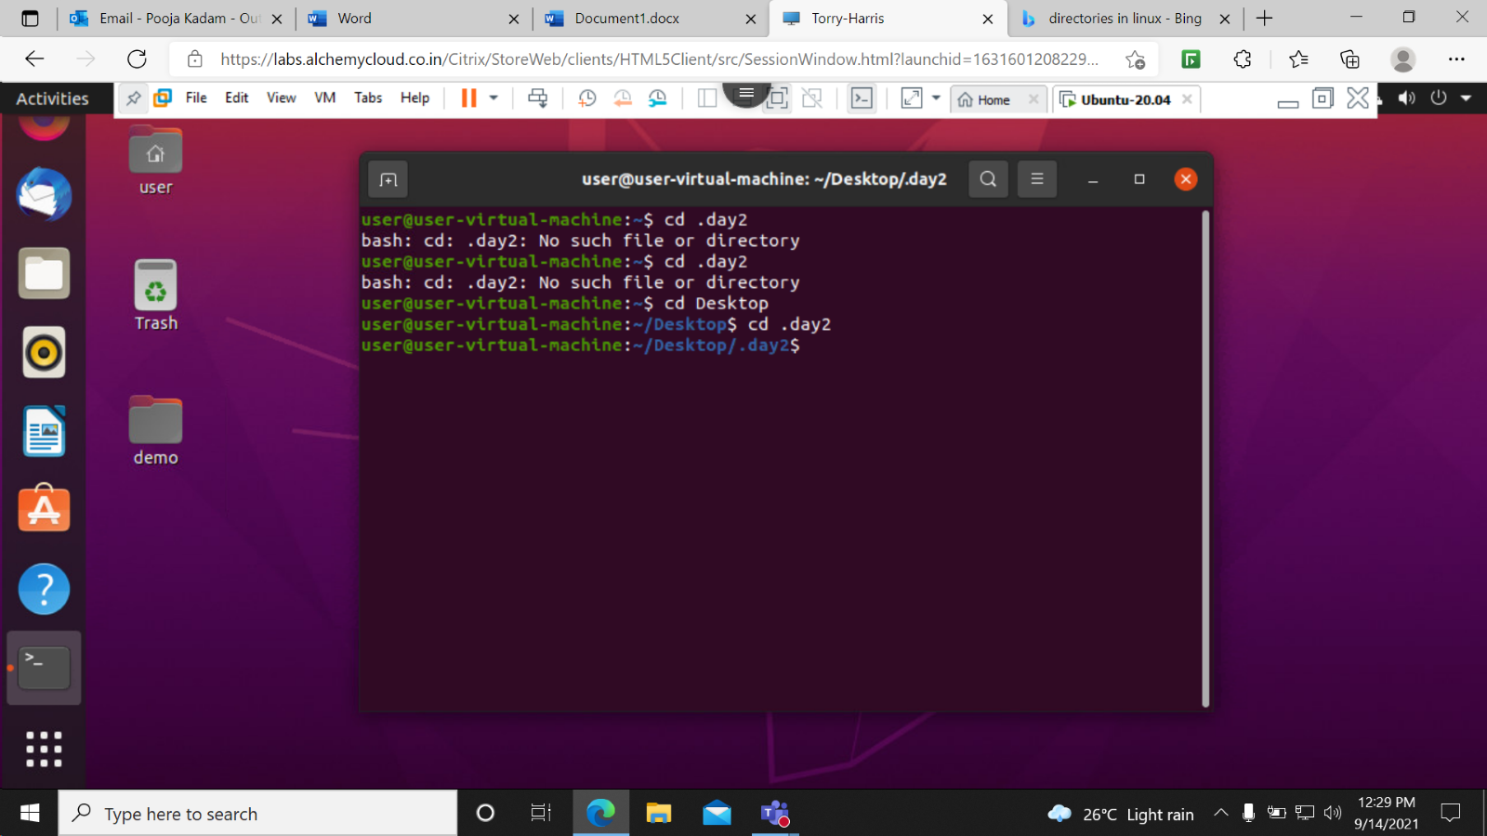

cd ..-Used to land on previous step.

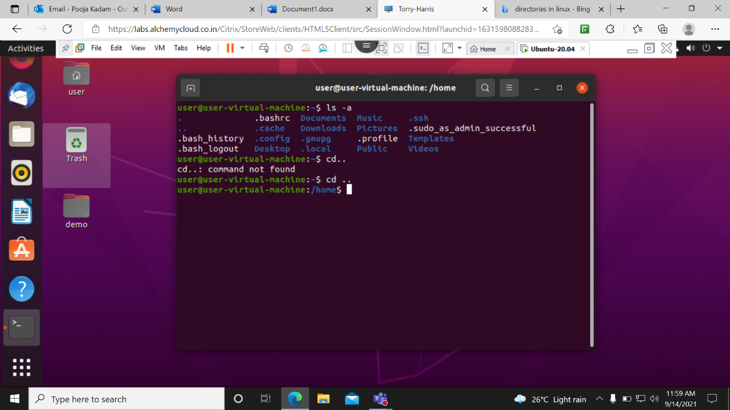

mkdir Demo- use to create a directory with the the name demo.

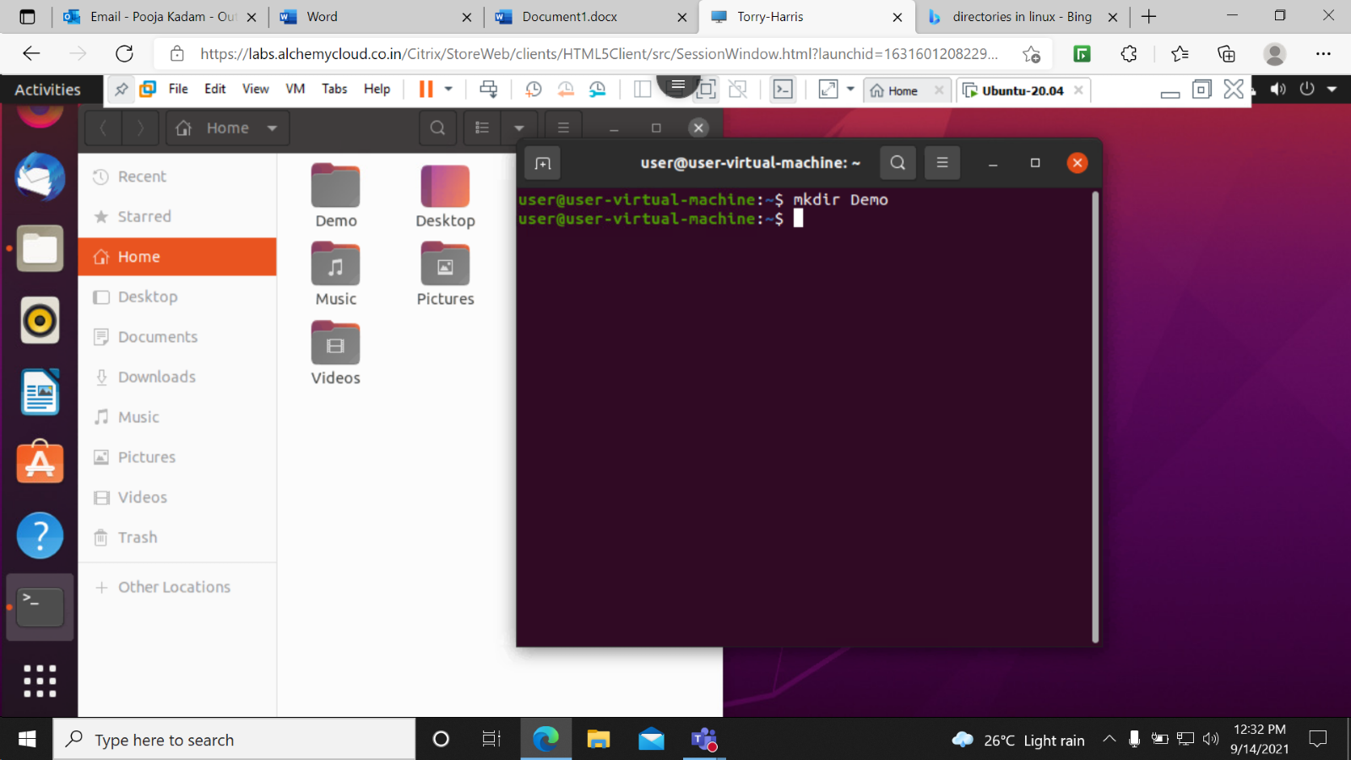

rmdir Demo- Used to remove a directory with the name Demo.

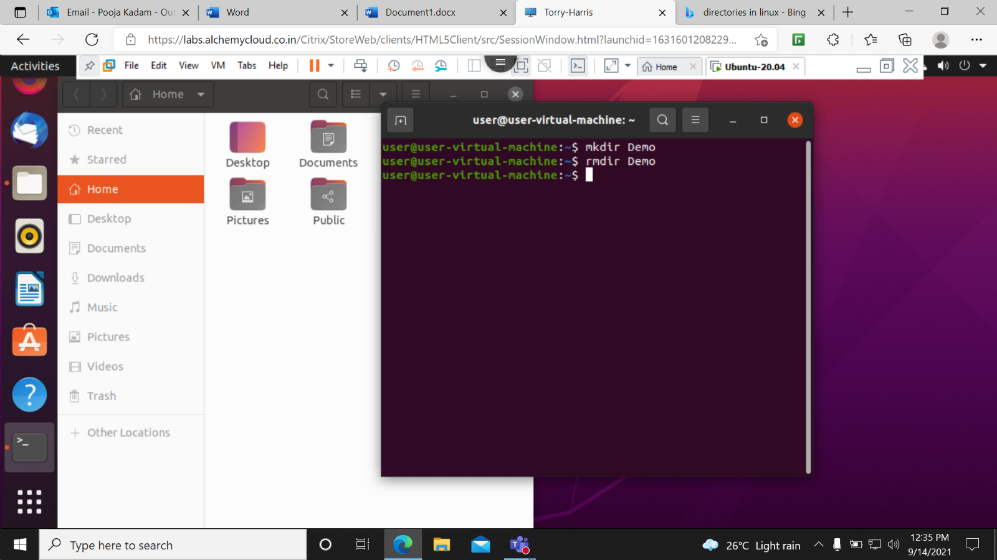

ls -A- it show all the files except the hidden file or it ignore the hidden file.

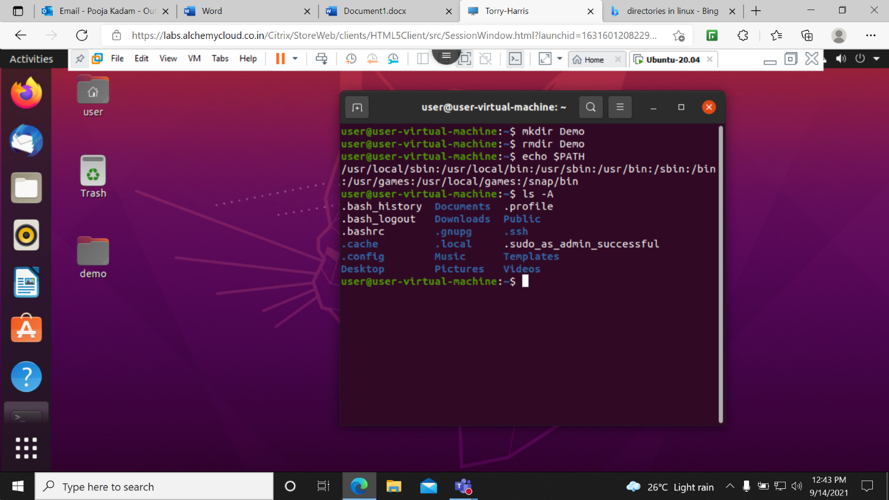

cat textfile-Used to read the contents from the tet file.

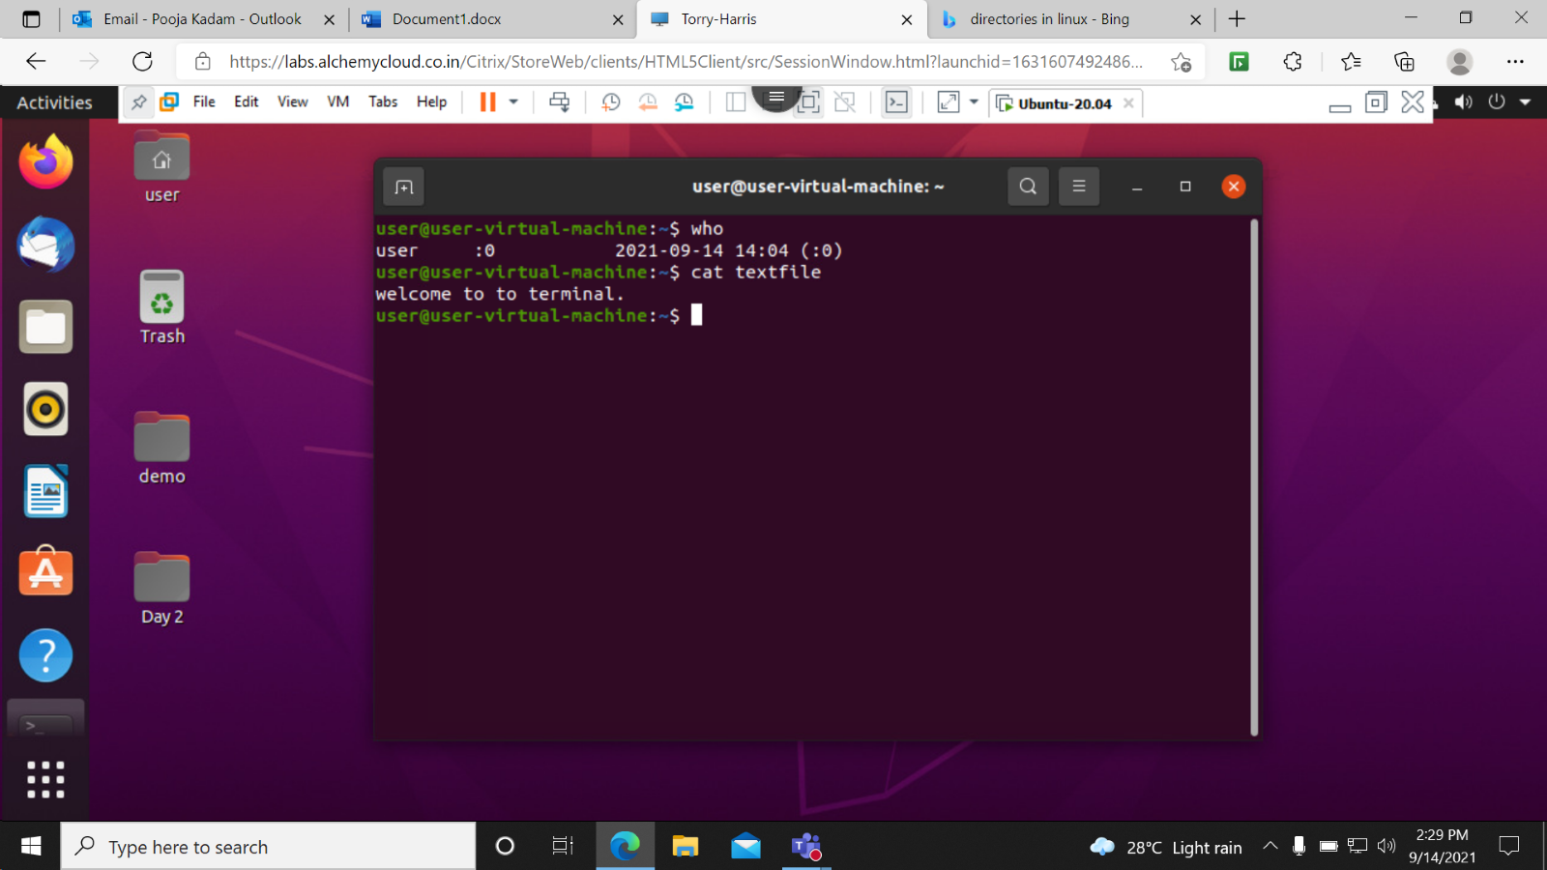

Who-It shows the details of current user.

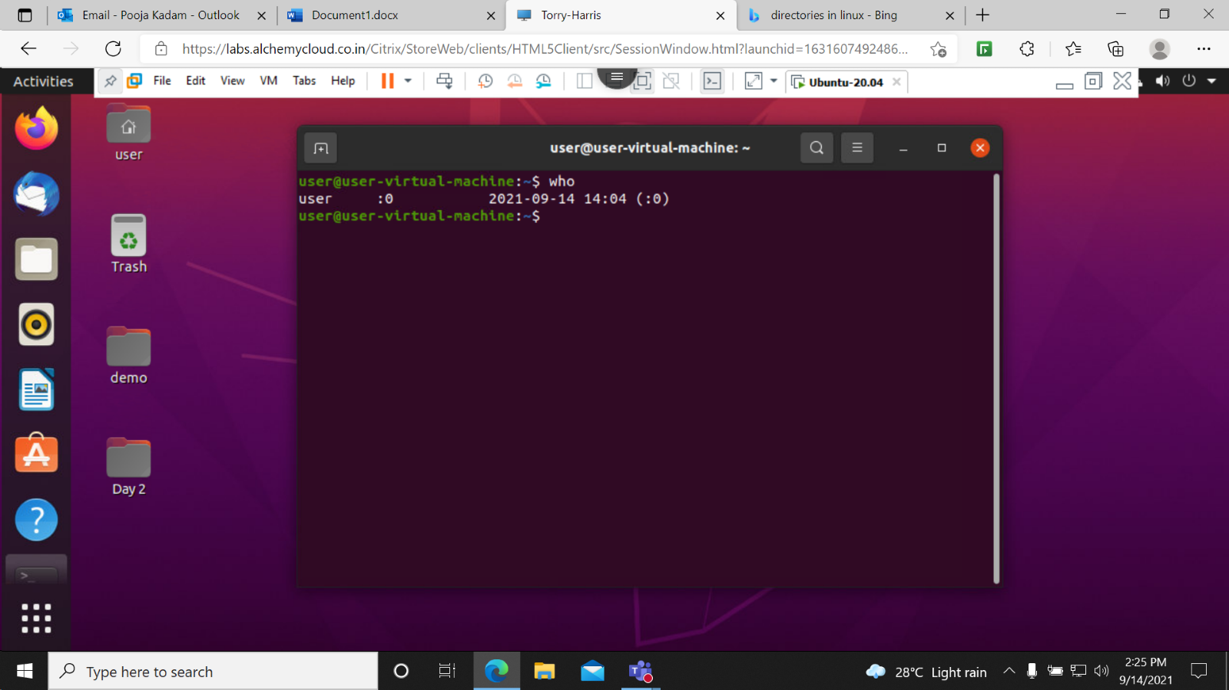

ls ‘Desktop/demo’- Used to access demo folder on desktop.

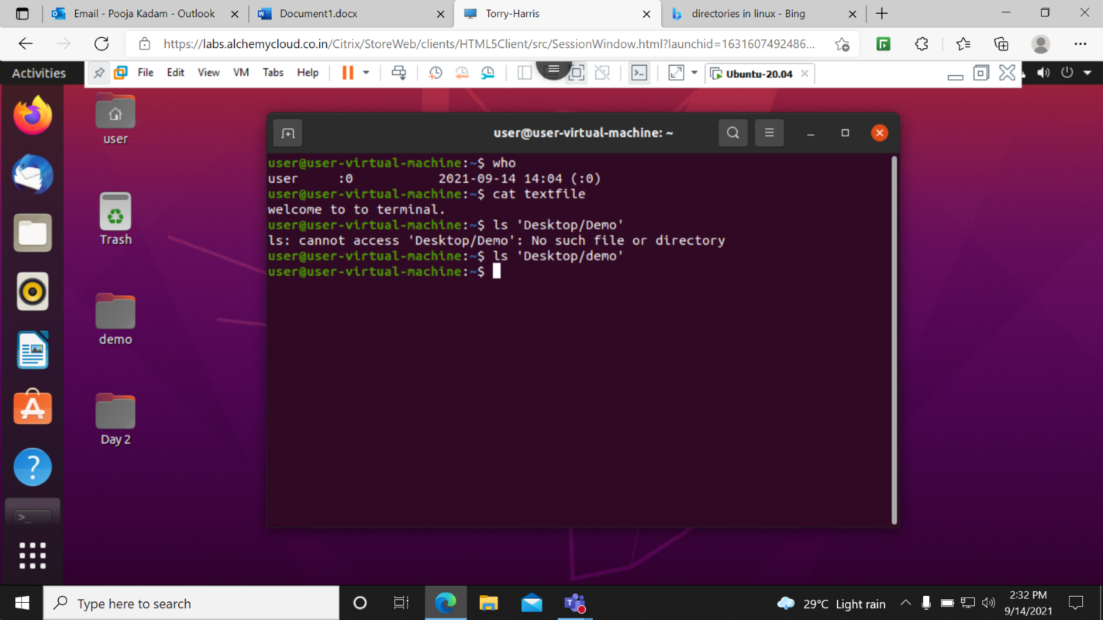

cal- Used to access calender.

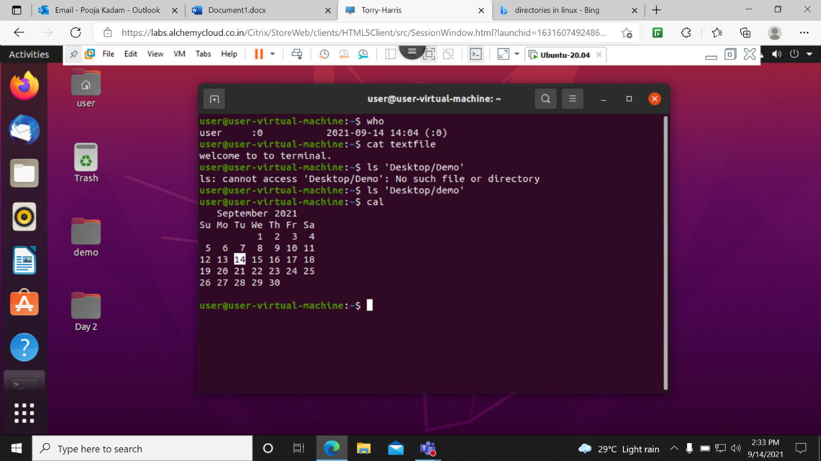

date-Used to access the today’s date as wll as time on terminal.

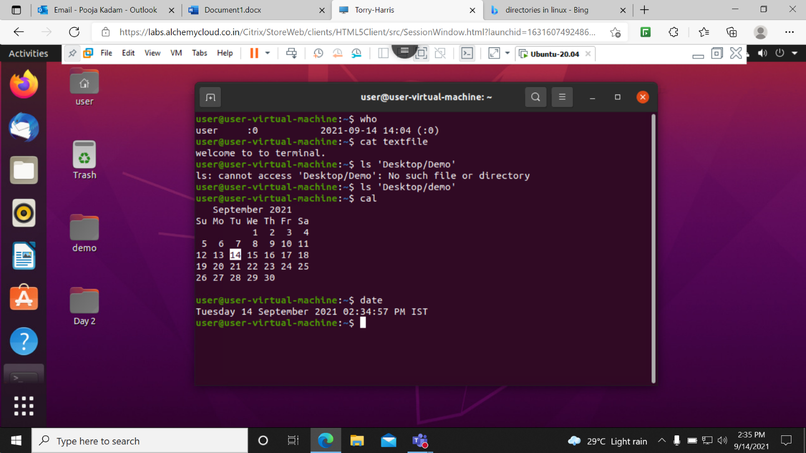

touch ‘Desktop/demo/folder1/z/t’-used to create a empty file inside a folder.

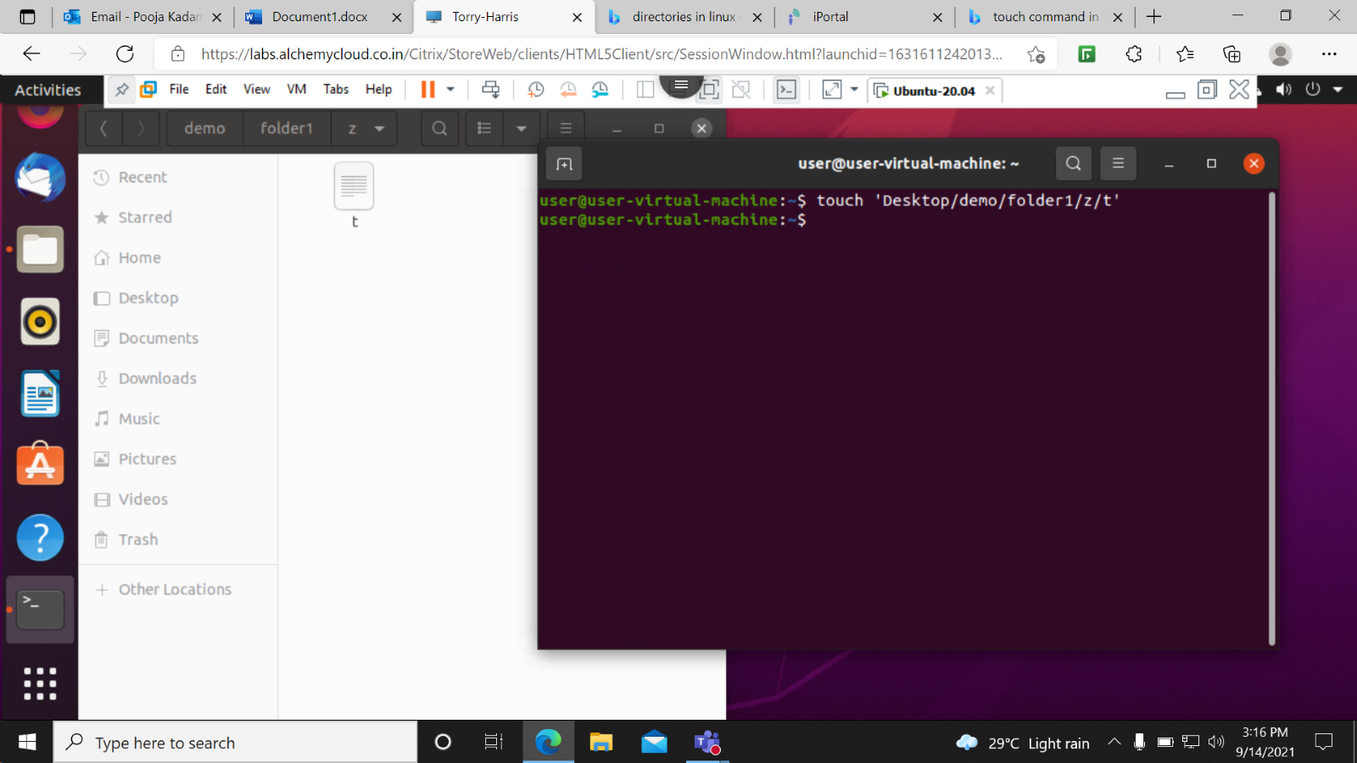

rm ‘Desktop/demo/folder1/z/t’-Used to delete a file.

